Project Name: Music Mart Insights

Database link: <https://drive.google.com/file/d/18ZytGB8NIr1NSIVgC4qyT9IfQoV48Nl/view?usp=sharing>

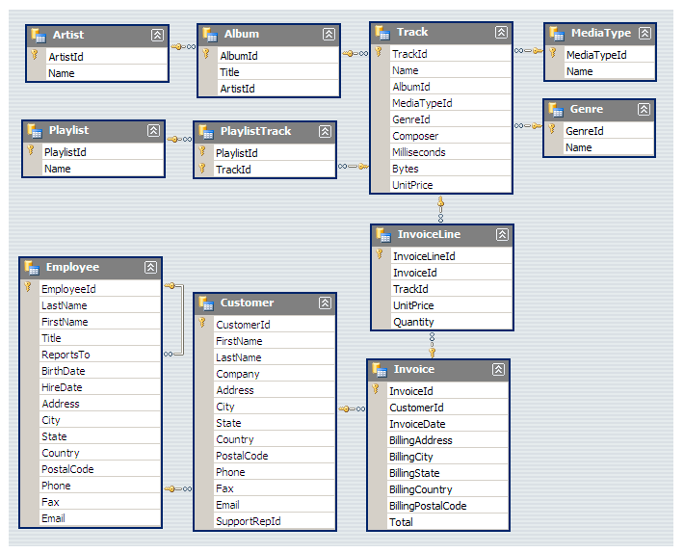Schema Diagram:

**Question Set 1 - Easy**

Q1: Who is the senior most employee based on job title?

SELECT title, last_name, first_name

FROM employee

ORDER BY levels DESC

LIMIT 1





Q2: Which countries have the most Invoices?

SELECT COUNT(*) AS c, billing_country

FROM invoice

GROUP BY billing_country

ORDER BY c DESC

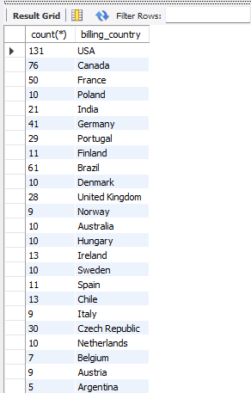

Q3: What are top 3 values of total invoice? */

SELECT total

FROM invoice

ORDER BY total DESC

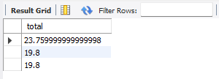

Q4: Which city has the best customers? We would like to throw a promotional Music Festival in the city we made the most money.

Write a query that returns one city that has the highest sum of invoice totals.

Return both the city name & sum of all invoice totals

SELECT billing_city,SUM(total) AS InvoiceTotal

FROM invoice

GROUP BY billing_city

ORDER BY InvoiceTotal DESC

LIMIT 1;

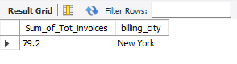

Q5: Who is the best customer? The customer who has spent the most money will be declared the best customer.

Write a query that returns the person who has spent the most money.

SELECT customer.customer_id, first_name, last_name, SUM(total) AS total_spending

FROM customer

JOIN invoice ON customer.customer_id = invoice.customer_id

GROUP BY customer.customer_id

ORDER BY total_spending DESC

LIMIT 1;

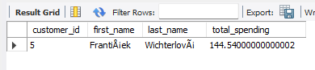

Note : IF YOU GOT THE ERROR LIKE THIS --.>

Error Code: 1055. Expression #2 of SELECT list is not in GROUP BY clause and contains nonaggregated column 'sql_project.customer.first_name' which is not functionally dependent on columns in GROUP BY clause; this is incompatible with sql_mode=only_full_group_by 0.000 sec

SOLUTION : (Run this command and then rerun your group by query )

set sql_mode = (SELECT REPLACE(@@sql_mode, 'ONLY_FULL_GROUP_BY',''));

**Question Set 2 - Moderate**

Q1: Write query to return the email, first name, last name, & Genre of all Rock Music listeners.

Return your list ordered alphabetically by email starting with A

SELECT DISTINCT email AS Email,first_name AS FirstName, last_name AS LastName, genre.name AS Name

FROM customer

JOIN invoice ON invoice.customer_id = customer.customer_id

JOIN invoiceline ON invoiceline.invoice_id = invoice.invoice_id

JOIN track ON track.track_id = invoiceline.track_id

JOIN genre ON genre.genre_id = track.genre_id

WHERE genre.name LIKE 'Rock'

ORDER BY email;

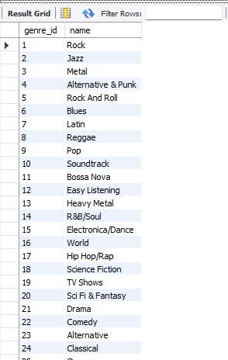

Q2: Let's invite the artists who have written the most rock music in our dataset.

Write a query that returns the Artist name and total track count of the top 10 rock bands

SELECT artist.artist_id, artist.name,COUNT(artist.artist_id) AS number_of_songs

FROM track

JOIN album ON album.album_id = track.album_id

JOIN artist ON artist.artist_id = album.artist_id

JOIN genre ON genre.genre_id = track.genre_id

WHERE genre.name LIKE 'Rock'

GROUP BY artist.artist_id

ORDER BY number_of_songs DESC

LIMIT 10;

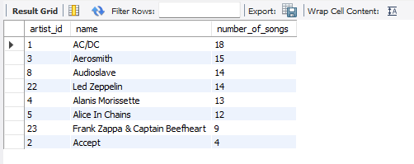

Q3: Return all the track names that have a song length longer than the average song length.

Return the Name and Milliseconds for each track. Order by the song length with the longest songs listed first.

SELECT name,miliseconds

FROM track

WHERE miliseconds > (

SELECT AVG(miliseconds) AS avg_track_length

FROM track )

ORDER BY miliseconds DESC;

|  |  |
| --- | --- |
|  |  |

**Question Set 3 - Advance**

Q1: Find how much amount spent by each customer on artists? Write a query to return customer name, artist name and total spent

WITH best_selling_artist AS (

SELECT artist.artist_id AS artist_id, artist.name AS artist_name, SUM(invoice_line.unit_price*invoice_line.quantity) AS total_sales

FROM invoice_line

JOIN track ON track.track_id = invoice_line.track_id

JOIN album ON album.album_id = track.album_id

JOIN artist ON artist.artist_id = album.artist_id

GROUP BY 1

ORDER BY 3 DESC

LIMIT 1

)

SELECT c.customer_id, c.first_name, c.last_name, bsa.artist_name, SUM(il.unit_price*il.quantity) AS amount_spent

FROM invoice i

JOIN customer c ON c.customer_id = i.customer_id

JOIN invoice_line il ON il.invoice_id = i.invoice_id

JOIN track t ON t.track_id = il.track_id

JOIN album alb ON alb.album_id = t.album_id

JOIN best_selling_artist bsa ON bsa.artist_id = alb.artist_id

GROUP BY 1,2,3,4

ORDER BY 5 DESC;

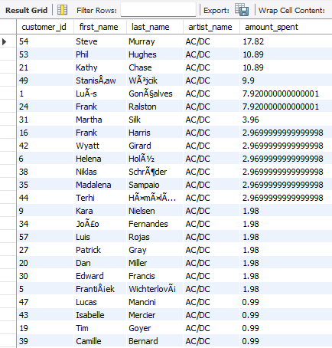

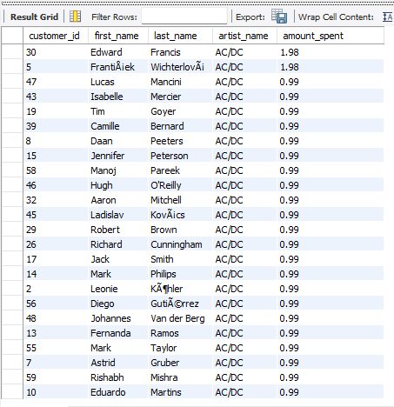

Q2: We want to find out the most popular music Genre for each country. We determine the most popular genre as the genre

with the highest amount of purchases. Write a query that returns each country along with the top Genre. For countries where

the maximum number of purchases is shared return all Genres.

Using CTE Method:

WITH popular_genre AS

(

SELECT COUNT(invoice_line.quantity) AS purchases, customer.country, genre.name, genre.genre_id,

ROW_NUMBER() OVER(PARTITION BY customer.country ORDER BY COUNT(invoice_line.quantity) DESC) AS RowNo

FROM invoice_line

JOIN invoice ON invoice.invoice_id = invoice_line.invoice_id

JOIN customer ON customer.customer_id = invoice.customer_id

JOIN track ON track.track_id = invoice_line.track_id

JOIN genre ON genre.genre_id = track.genre_id

GROUP BY 2,3,4

ORDER BY 2 ASC, 1 DESC

)

SELECT * FROM popular_genre WHERE RowNo <= 1

